1. Create a directory(repository)

mkdir example

cd example

ls –la

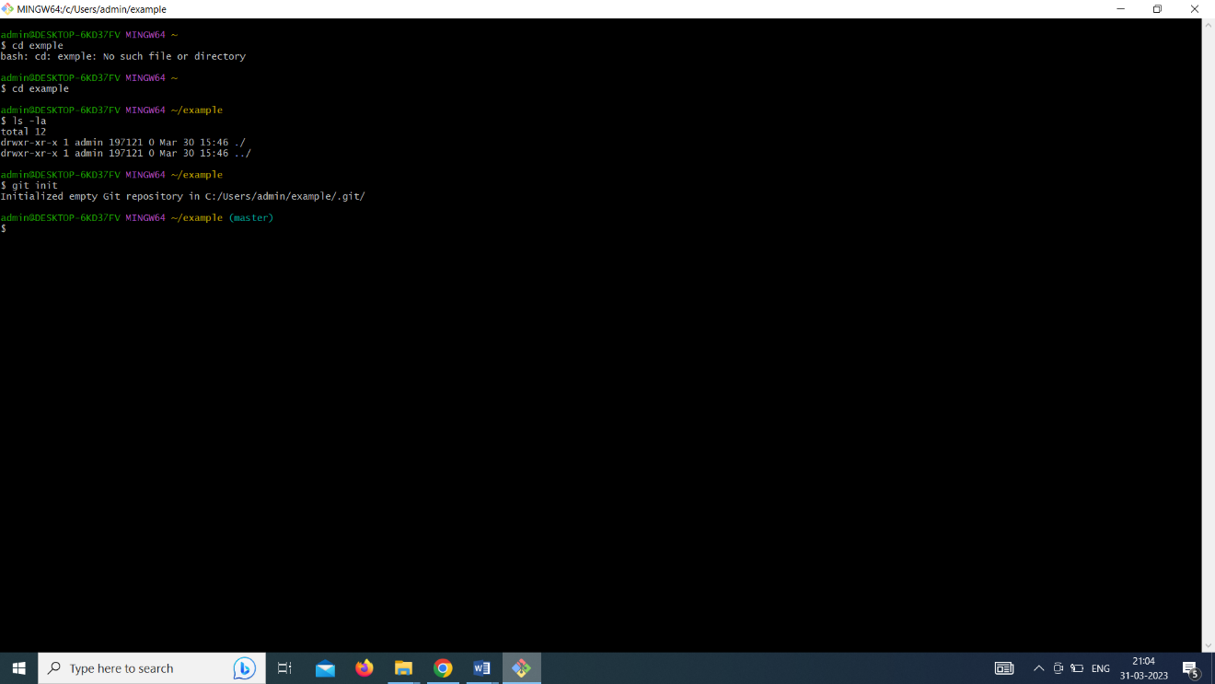2. git init (initializing the repository)

ls –la

ls –la .git

cat .git/config

git config --local user.name "vani"

cat .git/config

vim sample.html

git status

git add sample.html

git status

git rm --cached sample.html

git status

git commit -m "my first commit"

git status

git branch

git log

git diff

git show 3be2fcfaf290cbd0603ef8824c39737df63008dc

git branch IIBCA

git branch

git checkout IIBCA